1. Create a table student with the following fields: sid, sname, dept, mark1, mark2. Insert values to the table.
2. Add grade column to the student.
3. Describe student table.
4. Rename grade column to CGPA.
5. Modify datatype of sname of student table from varchar to char.
6. Drop column mark2 from student table.
7. Rename student table to student details.

**SQL> CREATE TABLE student (sid INT PRIMARY KEY, sname VARCHAR(20), dept VARCHAR(20), mark1 INT, mark2 INT);**

Table create

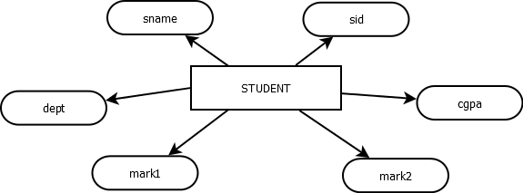

Answers:

* 1. **SQL> ALTER TABLE student ADD grade char;**

Table altered

* 1. **SQL> desc student;**

Name Null? Type

----------------------------------------- -------- ----------------------------

SID NOT NULL NUMBER(38)

SNAME VARCHAR2(20)

DEPT VARCHAR2(20)

MARK1 NUMBER(38)

MARK2 NUMBER(38)

GRADE CHAR(1)

* 1. **SQL> ALTER TABLE student RENAME COLUMN grade TO cgpa;**

Table altered

* 1. **SQL> ALTER TABLE student MODIFY sname char(20);**

**Table altered**

* 1. **SQL> ALTER TABLE student DROP COLUMN mark2;**

Table altered

* 1. **SQL> RENAME student TO student_details;**

Table renamed